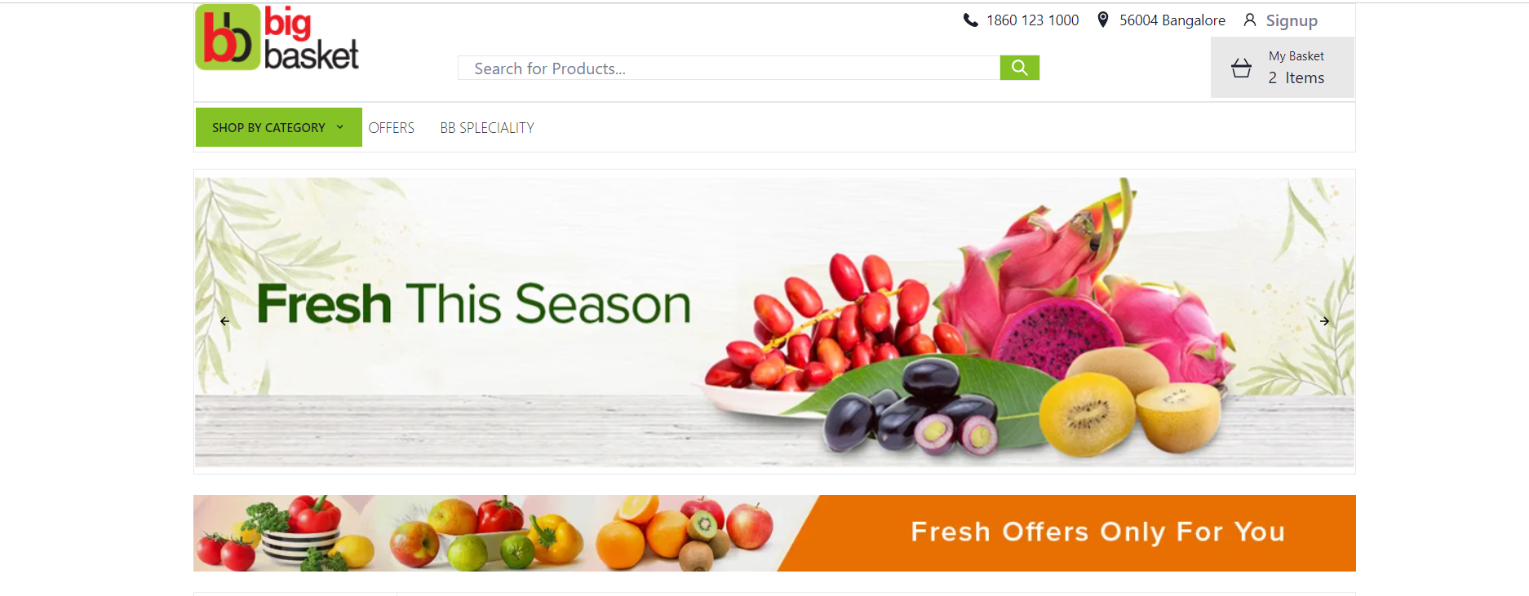

PROJECT NAME: Big Basket

## OVERVIEW

Big Basket is an online grocery store that offers a wide range of products such as fresh fruits, vegetables, meat, poultry, dairy products, and more. The company was founded in 2011 by Hari Menon, Vipul Parekh, Abhinay Choudhari, and V.S Sudhakar. It operates in over 25 cities across India and has over 18,000 products on its platform.

One of the key advantages of Big Basket is the convenience it offers to its customers. Customers can order groceries from the comfort of their homes and get them delivered to their doorstep. The platform also offers a wide range of payment options, including cash on delivery, credit and debit cards, and e-wallets.

## PAGES

* HOME PAGE
* SIGN IN/ SIGN UP
* PRODUCT PAGE
* CART
* PAYMENT GATEWAY

## PAGE OUTLINE

### HOME PAGE

**HEADER**

* LOGO
* WISH LIST
* CART
* SIGN IN/ SIGNUP

**SEARCH BAR**

* Shop by category (side panel)
* Search for product (below header)

**BODY**

* SLIDERS WITH ARROWS - (IMAGES)
* DEALS - (IMAGES)
* PRODUCTS
* FEATURED - (IMAGES)
* TRENDING - (IMAGES)

**FOOTER**

* CONTACT US
* ABOUT THE COMPANY
* SOCIAL-MEDIA
* LINK TO MOBILE APP

### SIGN IN/ SIGN UP

**SIGN UP**

* Name field
* E-mail address field
* Location field
* Detailed address
* Phone number field
* Sign up button

**SIGN IN**

* Log in field
* Password field
* Submit button

### PRODUCT PAGE

**FILTERS TOGGLE**

* Sort by price
* User rating
* Price ranges
* Popular brands
* Discount

**ITEM LOG**

* Each item in separate division.
* Image of item and name
* Option to buy and add to cart
* Increase the quantity of item
* User rating
* Discount offers if available

### CART

1. Detailed product summary with image
2. Cart subtotal and total
3. Assurances to reduce purchase anxiety
4. Check out button
5. Continue shopping button
6. Cart editing tools

### SHIPPING & PAYMENT

ADDRESS OF DELIVERY

PAYMENT MODE

PAYMENT GATEWAY

## TECHNOLOGIES USED

### Front-End:

* Html
* CSS
* Bootstrap
* React

### Dynamic:

* JavaScript
* Ci/Cd with AWS
* Login and Logout (OAuth and JWT)

### Database:

* MongoDB
* JSON Data

### Code compilers:

* Visual Studio Code
* Git bash
* GitHub
* Node.js.

## Home page overview

